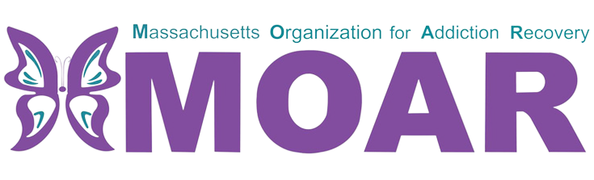

MetroWest Opioids Fact Sheet

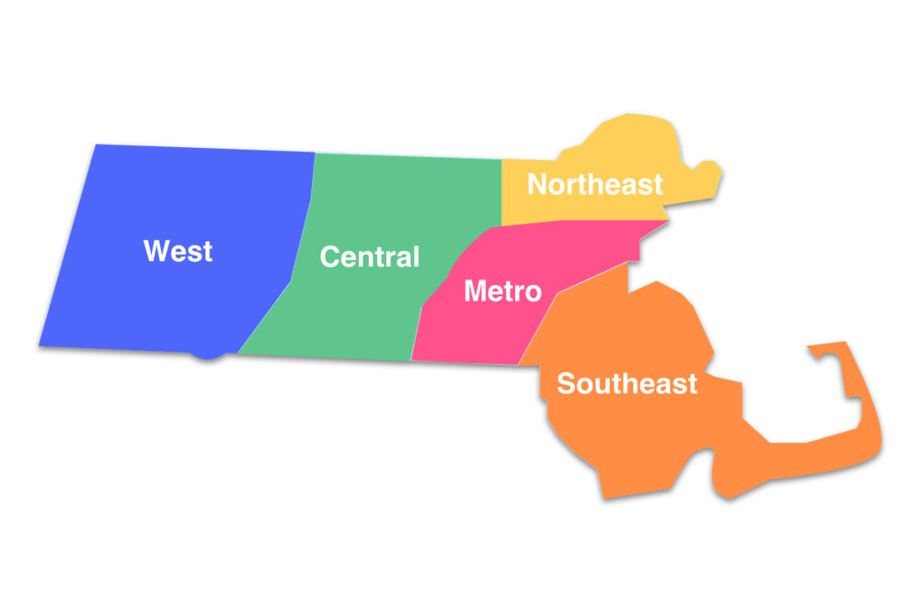

In 2021, the total number of confirmed opioid-related overdose deaths per county were 360 in Middlesex, and 165 in Norfolk.

What are opioids?

Opioids are a type of drug that is prescribed to reduce pain. The frequent use of opioids can lead to developing tolerance and dependence.

City/Town  across  MetroWest MA | Total opioid-related overdose deaths (2020) | Total opioid-related overdose deaths (2021)
Marlborough | 9 | 15
Holliston | 1 | 3
Lowell | 46 | 59
Quincy | 42 | 49
Walpole | 1 | 5
Framingham | 24 | 8
Weymouth | 25 | 19
Malden | 24 | 21
Brookline | 3 | 1
Between 2020 and 2021:
- Marlborough, Holliston, Lowell, Quincy, and Walpole had an increase in opioid-related overdose deaths.
- Framingham, Weymouth, Malden, and Brookline had a decrease in opioid-related overdose deaths.
In 2021, the total number of confirmed opioid-related deaths was 165. There were 9 more deaths reported compared to the previous year.
What is the current situation in Norfolk County?

This fact sheet provides the most recent data on opioid statistics published by Massachusetts Department of Public Health. For more information, please visit the website at
https://www.mass.gov/lists/current-opioid-statistics

