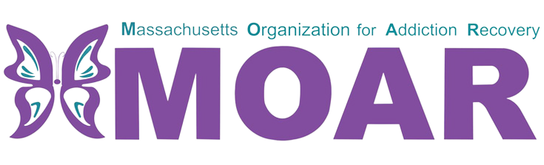

Metro Boston Opioids Fact Sheet
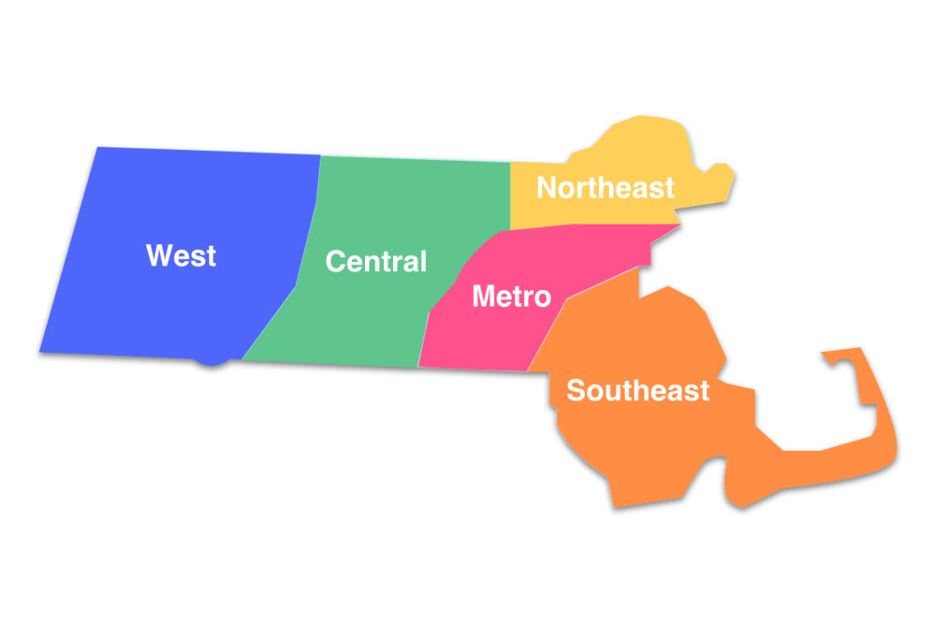

What are opioids?

In 2021, the total number of confirmed opioid-related overdose deaths per county were 295 in Suffolk.
Opioids are a type of drug that is prescribed to reduce pain. The frequent use of opioids can lead to developing tolerance and dependence.

City/Town  across  Metro Boston MA | Total opioid-related overdose deaths (2020) | Total opioid-related overdose deaths (2021)
Boston | 248 | 243
Revere | 21 | 25
Chelsea | 12 | 10
Winthrop | 6 | 6
Between 2020 and 2021:
- Boston and Chelsea had a decrease in opioid-related overdose deaths.
- Revere had an increase in opioid-related overdose deaths.
- Winthrop did not have any change in opioid-related overdose deaths.

What is the current situation in Suffolk County?

In 2021, the total number of confirmed opioid-related deaths was 295. There were 6 more deaths reported compared to the previous year.
This fact sheet provides the most recent data on opioid statistics published by Massachusetts Department of Public Health. For more information, please visit the website at
https://www.mass.gov/lists/current-opioid-statistics

